Bilkent University

Department of Computer Engineering

**Database Systems**

*Group 3: Pet Adoption and Care System*

*Project short-name: PetLink*

Project Proposal

Ahmet Alperen Yılmazyıldız - 22002712

Zeynep Doğa Dellal - 22002572

Borga Haktan Bilen - 22002733

Kardelen Ceren - 22003017

Yusuf Şenyüz - 21903105

Instructor: Özgür Ulusoy

Teaching Assistant(s): Mousa Farshkar Azari

**Contents**

1 Introduction 3

2 Project Description 3

3 Database Usage 4

4 Requirements 5

4.1 Functional Requirements 5

**4.1.1 Shelter** 5

**4.1.2 Adopter** 5

**4.1.3 Veterinarian** 5

**4.1.4 Administrator** 5

4.2 Non-functional Requirements 6

**4.2.1 Scalability** 6

**4.2.2 Reliability** 6

**4.2.3 Performance** 6

**4.2.4 Usability** 6

4.3 Pseudo Requirements 7

5 Limitations 7

6 ER Diagram 9

# Introduction

There are a lot of animals who need owners and suitable and loving homes. Shelters and rescue organizations try to find available adopters however, due to overpopulation and limited resources it is hard to find a home for each pet.

Another problem is that people who want to adopt pets may not find animals in need. Pet adoption process can be difficult for these reasons because there is no contact method between shelters and pet adopters. Pet adopters cannot find the pets that meet the criteria they want such as species, breed, age, gender, neuter status, and vaccination status of the particular pet. In addition, adopters must care for their pets and vaccinate adopted animals. This process must be checked by some medical professionals who are veterinarians.

The platform will solve these problems by bringing together shelters, adopters, and veterinarians. Adopters will be able to find potential pets by listing available pets for their criteria. Similarly, shelters will be able to demonstrate their available pets to the adopters. Veterinarians might schedule appointments, access health records, and give expert advice on pet health and wellness by using the system. Moreover, the administrators manage the general operations such as the adoption process, verifying credentials, and ensuring that all pets receive proper care in their new homes. This promotes responsible pet ownership and enhances the overall adoption experience for shelters and adopters.

Furthermore, the system will have some features about the forums. Users may create forum posts about pets and other users may reply to these posts. Also, adopters will have a profile with adoption preferences, and they can see pets’ general characteristics and health background.

# Project Description

PetLink empowers animal shelters to list pets for adoption and manage adoption applications, while providing potential pet adopters with a user-friendly interface to search for their ideal furry companions, complete with comprehensive pet profiles detailing characteristics, health history, and adoption records. Adopters can also create their own pet profiles, submit adoption applications, and gain access to pet care information. Our platform fills the gap between pet owners and veterinarians, enabling scheduling of appointments, access to detailed medical records, and expert advice on pet health and wellness on forum boards. Additionally, administrators oversee the adoption process, ensuring responsible pet ownership, and promoting the well-being of all pets in their new homes. Additionally, PetLink fosters community engagement through a forum, where users can connect, ask for advice, and share their pet-related experiences with veterinarians.

# Database Usage

In this project, a well-structured database is required for efficient and persistent data management. This requirement arises due to the data requirements of the pet adoption and care system that contains a lot of information related to shelters, adopters, pets, and veterinarians. When shelters and veterinarians register with the system, they are expected to submit official documents and administrators are expected to verify these documents. Therefore, these documents and their respective verification statuses will be stored as entities and their relationships within our database system.

Administrators will also have the responsibility of overseeing the well-being of adopted pets and maintaining records of the pets they have overseen. These records will be stored as entities in the database. Additionally, the system must maintain records of pet adoption applications, veterinarian appointments, and detailed medical information about the pets. These pieces of information will be stored as separate entities in the database.

The system will allow adopters to view and filter animals based on their preferences. For this reason, the database must be designed to efficiently and accurately handle query requests to facilitate effective listing and filtering.

Lastly, all users will have access to a forum section within the application to connect with one another, seek and provide advice on pet care-related topics, and ask questions to veterinarians about pet-related issues. For this purpose, forum posts and replies to those posts will be stored in the database.

To enable the functionalities mentioned above, it is crucial to design a well-structured database that can handle data retrieval, manipulation, insertion, and deletion operations without compromising data integrity and security.

# Requirements

## 4.1 Functional Requirements

### **4.1.1 Shelter**

* Shelters will have a profile.
* Shelters can list pets for adoption.
* Shelters can approve or decline adoption applications.
* Shelters can create forum posts.
* Shelters can reply to forum posts.
* Shelters can edit their credentials.

### **4.1.2 Adopter**

* Adopters will have a profile with adoption preferences.
* Adopters can see and filter different pets for adoption.
* Adopters can see pets’ general characteristics and health background.
* Adopters can add their own pets.
* Adopters can submit applications for adoption.
* Adopters can see general pet care information.
* Adopters can schedule appointments with a veterinarian.
* Adopters can access detailed medical records of their own pet.
* Adopters can create forum posts.
* Adopters can reply to forum posts.

### **4.1.3 Veterinarian**

* Veterinarians will have a profile.
* Veterinarians can log detailed medical records for a pet.
* Veterinarians can accept, postpone, or decline appointments.
* Veterinarians can create forum posts.
* Veterinarians can reply to forum posts.
* Veterinarians’ forum replies will be at the top and will be differently colored to be visible.

### **4.1.4 Administrator**

* Administrators will evaluate shelters and veterinarians’ sign-up requests based on the official documents provided.
* Administrators can add general pet care information.
* Every six months after a pet is adopted, administrators selected by the system will be notified to oversee (i.e., oversee record) and then evaluate the care the pet is receiving.

## 4.2 Non-functional Requirements

### **4.2.1 Scalability**

One of the primary functionalities of the application is its capacity to handle requests of a large number of users from around the world. Thus, the system should not limit the number of users nor cause any performance degradation induced by the number of users. So, the design of the database should be made in a manner that enables it to effectively handle a considerable user load.

### **4.2.2 Reliability**

The app needs to be able to perform operations with the database without accidentally losing any information. To ensure this, we should make copies of the database regularly to make sure the data is safe in case something bad happens, such as a system crash.

* The database used in the application will be backed up every 12 hours to minimize the effects of any unintentional data loss.

### **4.2.3 Performance**

The program must respond quickly to user requests (i.e., database queries) and shouldn't slow down or pause when users interact with it.

* For any given database query sent to the database, the response time should be in the order of millisecond.
* End-users should be able to see any filtered results of their queries/searches in less than 5 seconds.
* Adoption application forms, from adopters to shelters, should be sent within 5 seconds, after being submitted.

### **4.2.4 Usability**

The system needs to have a user-friendly interface that anyone can easily understand. Thus, it should be concise and clutter-free.

* The color palette of the application should be composed of softer colors, such as ecru, gray, or white.
* Throughout the design of the user interface, responsive design patterns and approaches will be utilized. Thus, the application can be used on devices with different screen sizes (such as, 360x640 or 1920x1080).
* Navigation should be maintained with a fixed (permanent) navbar at the top of the page, which will always be on display regardless of what page is active.
* A search bar should be present on the homepage of the application to make the query functionality more accessible.
* “Toastr” should be used to provide immediate feedback to users when they perform actions in the application, such as submitting a form or deleting a form.

## 4.3 Pseudo Requirements

* MySQL database system will serve us as the database management system. It supports all modern database management system features that we will use in the project.
* The backend of the application will be implemented using the Flask framework for Python.
* The frontend of the application will be implemented using React.JS framework with TypeScript and to make the application’s look and feel more modern Tailwind CSS framework and Material UI components will be used.
* All the interactions between the database and the application will be made using sole SQL queries (in essence, automation tools and libraries, such as ORM, will not be used).

# Limitations

* Each post must have one user who created it.
* Each reply must have one user who created it and one associated post.
* Each medical record must have one associated pet and one veterinarian who logged it.
* Each overseeing record must have one administrator and one adopter associated with it.
* Each document must be uploaded by one user.
* Each pet care information must be written by one administrator.
* Each administrator will have a unique employee ID (different from the primary key) assumed to be used in the company’s internal organization in real life.
* Each user must enter an email, a password, a name, and a phone number on registration.
* Veterinarians must additionally enter their specialty, years of experience, and address on registration.
* Shelters must additionally enter their address.
* Only shelters can put a pet up for adoption.
* Shelters and veterinarians have to add official documents, such as licenses, for verification by the administrator to activate their accounts.
* Only administrators can write general pet care information.
* Any added pet must have their species, breed, age, gender, and whether it was neutered, vaccinated, and/or house-trained specified.
* Adopters must have entered their adoption preferences and previous pet care experience in years to apply for adoption.
* Administrators will have access to all pets and their medical records for overseeing the whole process of adoption and care taking.
* The overseeing record will be assigned to the administrator with the least number of records.

# ER Diagram

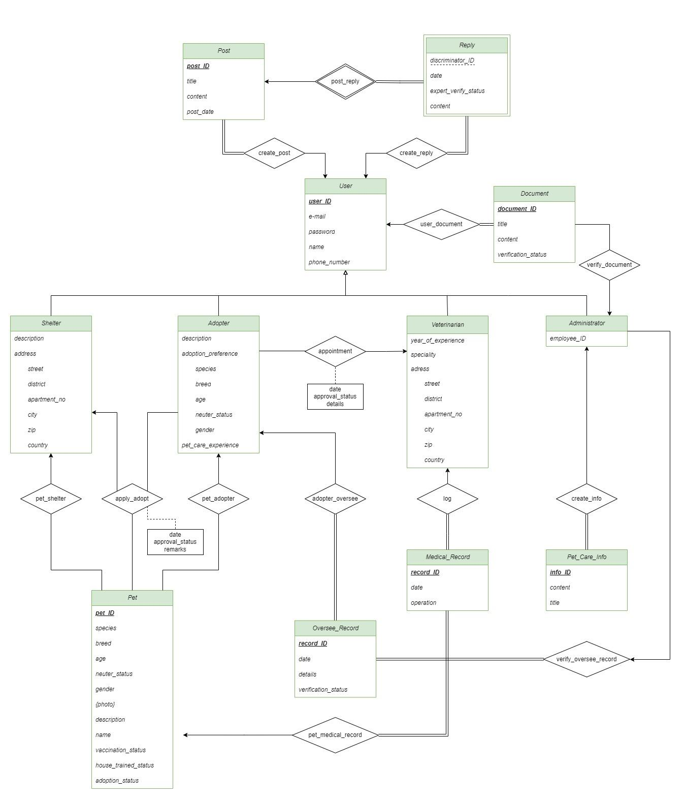

Figure 1: Entity/Relationship Diagram of PetLink

*Link to view the E-R diagram in detail:* [*https://viewer.diagrams.net/?tags=%7B%7D&highlight=0000ff&layers=1&nav=1&title=DB-Project-ER-Diagram.drawio#Uhttps%3A%2F%2Fdrive.google.com%2Fuc%3Fid%3D1LFV8WULKTMciQ2_akvlhcV9X9ZRII274%26export%3Ddownload*](https://viewer.diagrams.net/?tags=%7B%7D&highlight=0000ff&layers=1&nav=1&title=DB-Project-ER-Diagram.drawio#Uhttps%3A%2F%2Fdrive.google.com%2Fuc%3Fid%3D1LFV8WULKTMciQ2_akvlhcV9X9ZRII274%26export%3Ddownload)